React
9. ReactJS-HOL

Step 1: Create React Project
In your terminal (VS Code):
npx create-react-app PlayertApp
cd PlayertApp

Step 2: Create Components Folder
In the src/ folder:
- Right-click src > New Folder → name it Components
- Inside Components, create these 3 files:
  - ListofPlayers.js
  - Indian Players.js
Step 3: Code for Each Component

ListofPlayers.js

import React from 'react';

const ListofPlayers = () => {
const players = [
{ name: "Virat Kohli", score: 85 },
{ name: "Rohit Sharma", score: 45 },
{ name: "KL Rahul", score: 60 },
{ name: "Hardik Pandya", score: 75 },
{ name: "Ravindra Jadeja", score: 40 },
{ name: "Jasprit Bumrah", score: 90 },
{ name: "Shubman Gill", score: 95 },
{ name: "Shreyas Iyer", score: 30 },
{ name: "Mohammed Shami", score: 78 },
{ name: "Rishabh Pant", score: 88 },
{ name: "Axar Patel", score: 55 }
];

// ES6 arrow function to filter players with score < 70
const lowScorers = players.filter(player => player.score < 70);

return (
<div>
<h2>All Players:</h2>
<ul>
{players.map((player, i) => (
<li key={i}>{player.name} - {player.score}</li>
))}
</ul>

<h2>Players with Score below 70:</h2>
<ul>
{lowScorers.map((player, i) => (
<li key={i}>{player.name} - {player.score}</li>
))}
</ul>
</div>
);
};

export default ListofPlayers;

IndianPlayers.js

import React from 'react';

const IndianPlayers = () => {
const T20players = ["Virat", "Rohit", "Rahul", "Hardik", "Pant"];
const RanjiPlayers = ["Iyer", "Jadeja", "Gill", "Axar", "Shami"];

// Merge arrays using spread operator
const allPlayers = [...T20players, ...RanjiPlayers];

// Destructure into even and odd indexed players
const oddTeam = allPlayers.filter((_, index) => index % 2 !== 0);
const evenTeam = allPlayers.filter((_, index) => index % 2 === 0);

return (
<div>
<h2>All Merged Players:</h2>
<ul>
{allPlayers.map((name, i) => <li key={i}>{name}</li>)}
</ul>

<h2>Even Index Team:</h2>
<ul>
{evenTeam.map((name, i) => <li key={i}>{name}</li>)}
</ul>

<h2>Odd Index Team:</h2>
<ul>
{oddTeam.map((name, i) => <li key={i}>{name}</li>)}
</ul>
</div>
);
};

export default IndianPlayers;

Step 4: Modify App.js to Use Components
In src/App.js, update the code like this:
import React from 'react';
import ListofPlayers from './ListofPlayers';
import IndianPlayers from './IndianPlayers';

function App() {
const flag = true; // toggle this to false to see IndianPlayers

return (
<div className="App">
<h1>Cricket App</h1>
{flag ? <ListofPlayers /> : <IndianPlayers />}
</div>
);
}

export default App;

Step 5: Start the App
In your terminal:
npm start
Then open your browser and go to:
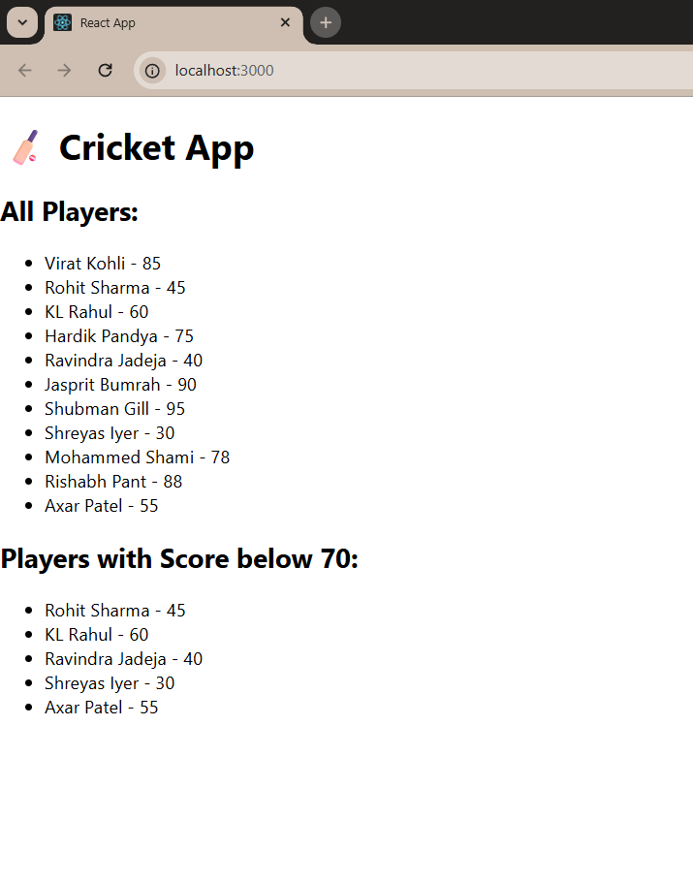
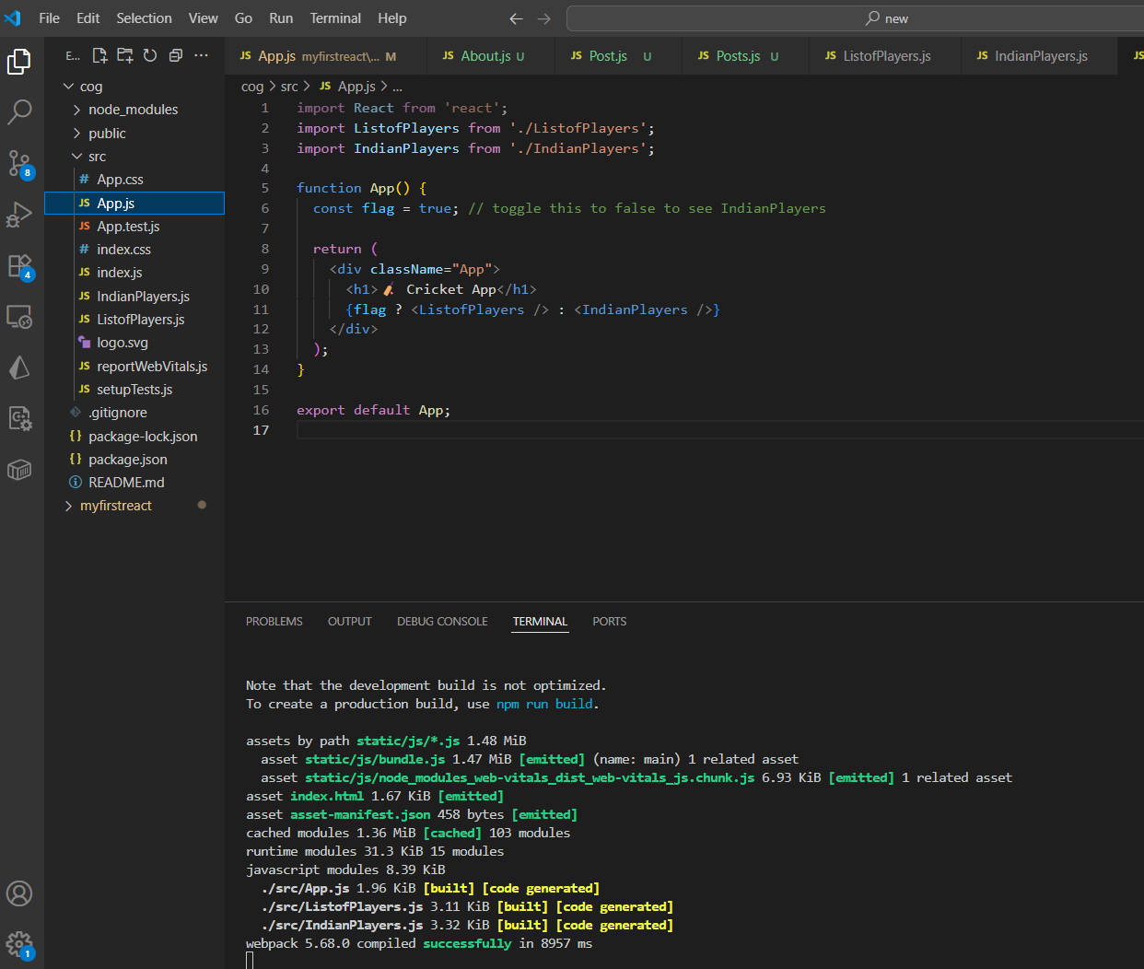
http://localhost:3000
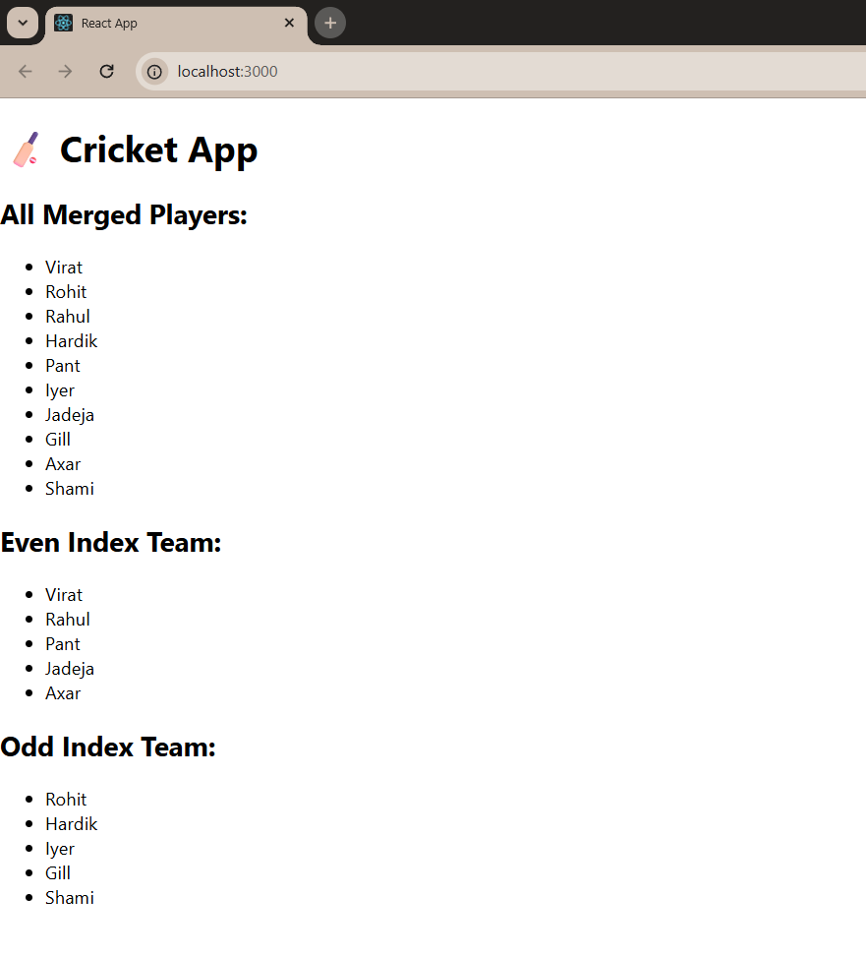

10. ReactJS-HOL

Step 1: Create React Project
In your terminal (VS Code):
npx create-react-app officeapp
cd officeapp

Step 2: Modify App.js and App.css
In src/App.js, update the code like this:
import React from 'react';
import './App.css';

function App() {
const heading = <h1>🏢 Office Space Rental Listings</h1>;

const imageUrl = "https://via.placeholder.com/600x300?text=Office+Space";

const office = {
name: "Premium Tech Park",
rent: 50000,
address: "Bangalore, India"
};

const officeList = [
{ name: "Eco Tower", rent: 45000, address: "Mumbai" },
{ name: "Skyline Plaza", rent: 72000, address: "Delhi" },
{ name: "Global Hub", rent: 61000, address: "Chennai" },
{ name: "WorkZone", rent: 30000, address: "Hyderabad" },
];

const getRentColor = (rent) => {
return { color: rent < 60000 ? "red" : "green" };
};

return (
<div className="App">
{heading}

<img src={imageUrl} alt="Office Space" style={{ width: '100%', maxHeight: '300px' }} />

<h2>Featured Office</h2>
<p><strong>Name:</strong> {office.name}</p>
<p><strong>Address:</strong> {office.address}</p>
<p><strong>Rent:</strong> <span style={getRentColor(office.rent)}>{office.rent}</span></p>

<h2>Other Office Listings</h2>
{officeList.map((item, index) => (
<div key={index} style={{ border: '1px solid #ccc', margin: '10px', padding: '10px', borderRadius: '8px' }}>
<p><strong>Name:</strong> {item.name}</p>
<p><strong>Address:</strong> {item.address}</p>
<p><strong>Rent:</strong> <span style={getRentColor(item.rent)}>{item.rent}</span></p>
</div>
))}
</div>
);
}

export default App;

App.css

.App {
font-family: 'Segoe UI', Tahoma, Geneva, Verdana, sans-serif;
padding: 20px;
background-color: #f9f9f9;
}
h1, h2 {
color: #333;
}

Step 5: Start the App
In your terminal:
npm start

Then open your browser and go to:
http://localhost:3000
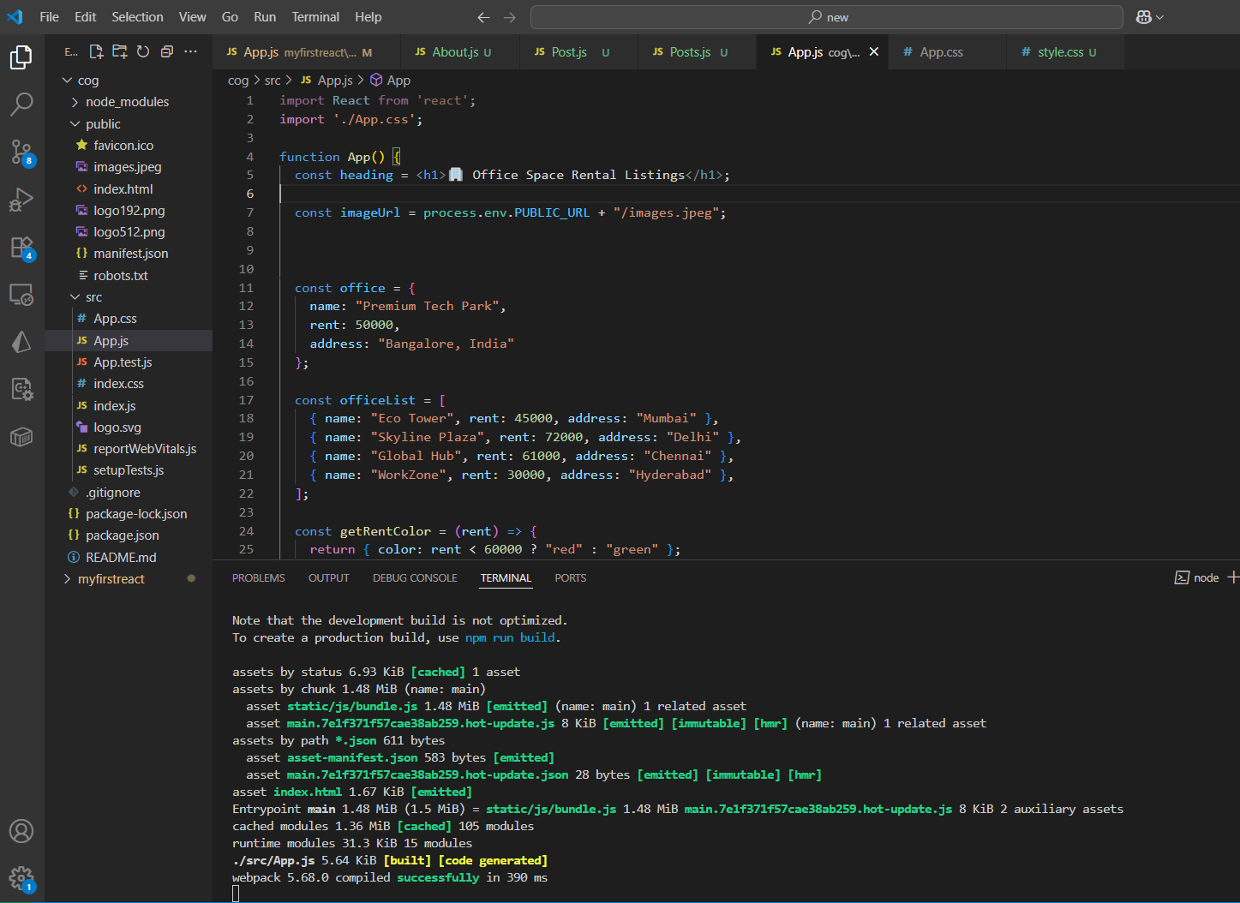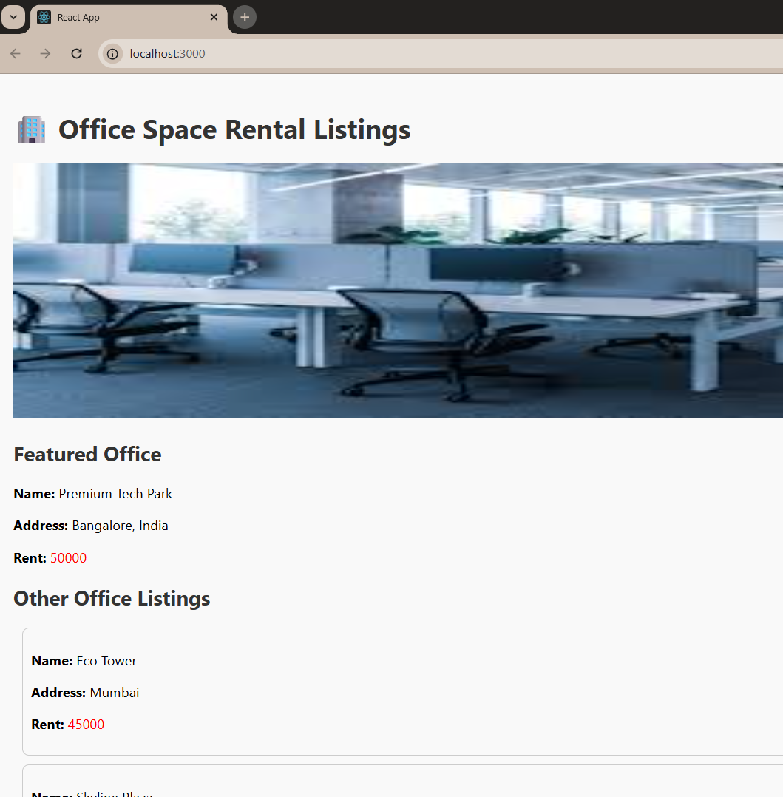

11. ReactJS-HOL

Step 1: Create React Project
In your terminal (VS Code):
npx create-react-app eventApp
cd eventApp

Step 2: Create Components Folder
In the src/ folder:
- Right-click src > New Folder → name it Components
- Inside Components, create these 1 files:
  - CurrencyConvertor.js

Step 3: Code for Each Component

CurrencyConvertor.js

import React, { useState } from 'react';

const CurrencyConvertor = () => {
const [rupees, setRupees] = useState('');
const [euro, setEuro] = useState('');

const handleSubmit = (e) => {
e.preventDefault();
const converted = parseFloat(rupees) / 89.5; // Example conversion rate
setEuro(converted.toFixed(2));
};

return (
<div>
<h2>Currency Converter (INR to Euro)</h2>
<form onSubmit={handleSubmit}>
<input
type="number"
placeholder="Enter amount in INR"
value={rupees}
onChange={(e) => setRupees(e.target.value)}
/>
<button type="submit">Convert</button>
</form>
{euro && <p>€ {euro}</p>}
</div>
);
};

export default CurrencyConvertor;

Step 4: Modify App.js to Use Components
In src/App.js, update the code like this:
import React, { Component } from 'react';
import CurrencyConvertor from './CurrencyConvertor';

class App extends Component {
constructor(props) {
super(props);
this.state = {
counter: 0,
};
}

increment = () => {
this.setState({ counter: this.state.counter + 1 });
this.sayHello();
};

sayHello = () => {
alert('Hello! This is a static message.');
};

decrement = () => {
this.setState({ counter: this.state.counter - 1 });
};

sayWelcome = (msg) => {
alert(msg);
};

handleClick = (e) => {
e.preventDefault(); // Synthetic Event
alert('I was clicked');
};

render() {
return (
<div className="App" style={{ padding: 20 }}>
<h1>React Events Example</h1>
<h2>Counter: {this.state.counter}</h2>

<button onClick={this.increment}>Increment</button>
<button onClick={this.decrement}>Decrement</button>

<hr />

<button onClick={() => this.sayWelcome("Welcome to React!")}>Say Welcome</button>

<hr />

<button onClick={this.handleClick}>Synthetic Event OnPress</button>

<hr />

<CurrencyConvertor />
</div>
);
}
}

export default App;

Step 5: Start the App
In your terminal:
npm start
Then open your browser and go to:
http://localhost:3000

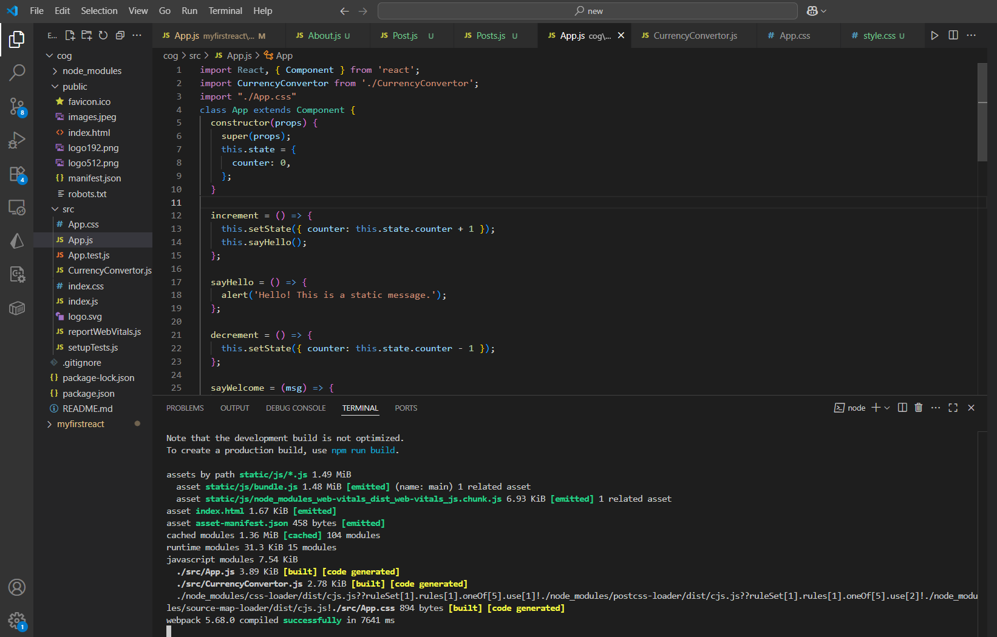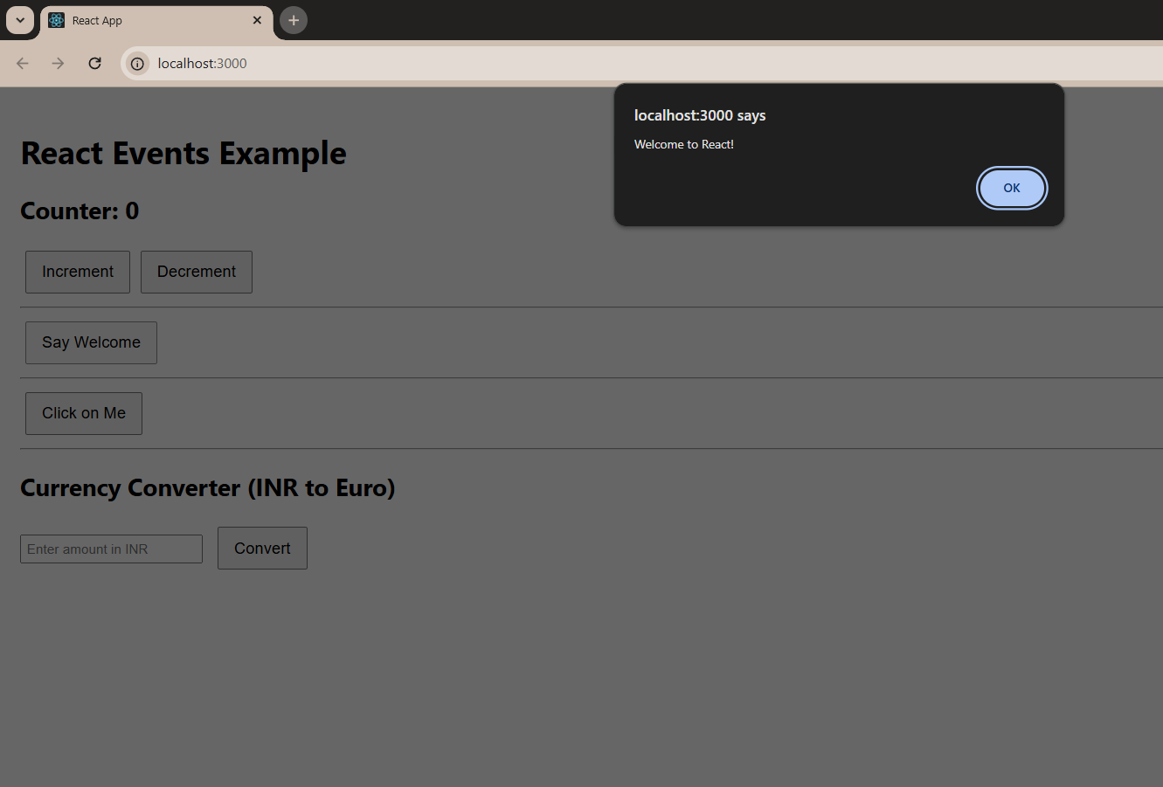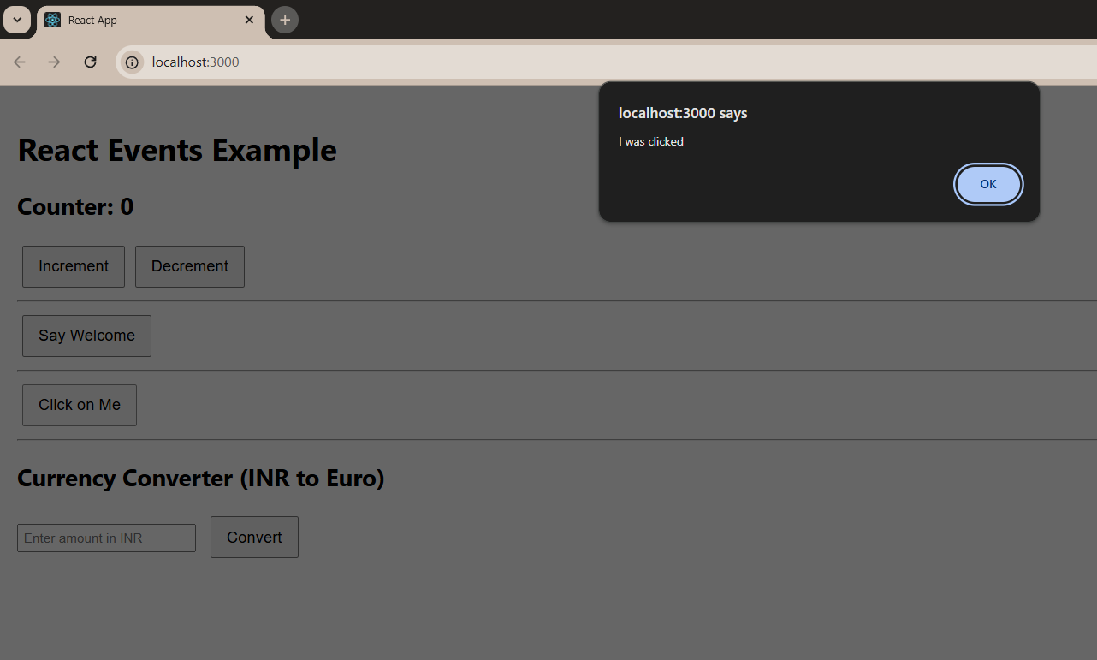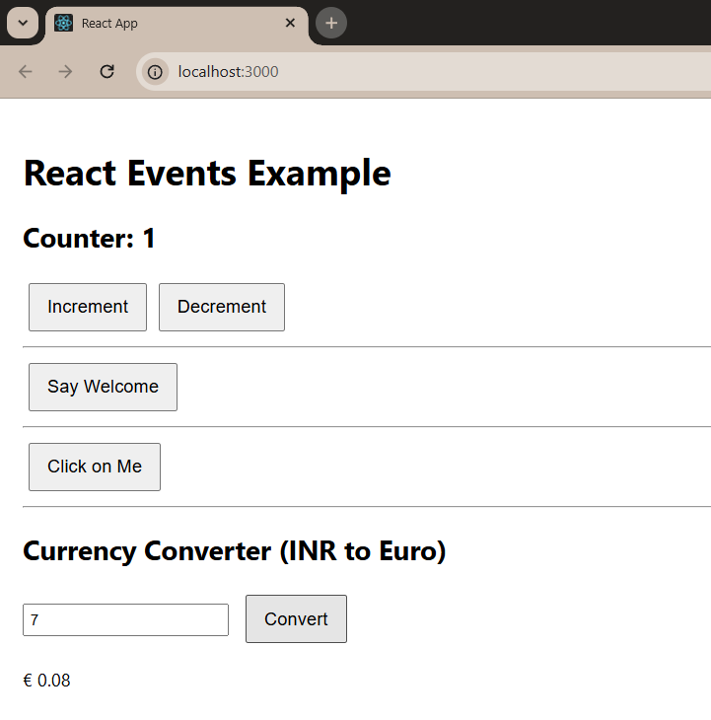
12. ReactJS-HOL

Step 1: Create React Project
In your terminal (VS Code):
npx create-react-app TicketApp
cd TicketApp

Step 2: Create Components Folder
In the src/ folder:
- Right-click src > New Folder → name it Components
- Inside Components, create these 2 files:
  - GuestPage.js
  - UserPage.js
Step 3: Code for Each Component

GuestPage.js

import React from 'react';

const GuestPage = () => {
return (
<div>
<h2>Welcome Guest!</h2>
<p>Here are the available flight details:</p>
<ul>
<li>✈️ Delhi to Mumbai - ₹4500</li>
<li>✈️ Bangalore to Chennai - ₹3200</li>
<li>✈️ Hyderabad to Pune - ₹4100</li>
</ul>
</div>
);
};

export default GuestPage;

UserPage.js

import React from 'react';

const UserPage = () => {
return (
<div>
<h2>Welcome Back, User!</h2>
<p>You can now book your tickets:</p>
<button>Book Delhi to Mumbai</button>
<button>Book Bangalore to Chennai</button>
<button>Book Hyderabad to Pune</button>
</div>
);
};

export default UserPage;
Step 4: Modify App.js and App.css
In src/App.js, update the code like this:
import React, { useState } from 'react';
import GuestPage from './GuestPage';
import UserPage from './UserPage';
import './App.css';

function App() {
const [isLoggedIn, setIsLoggedIn] = useState(false);

const loginHandler = () => setIsLoggedIn(true);
const logoutHandler = () => setIsLoggedIn(false);

let pageContent;
if (isLoggedIn) {
pageContent = <UserPage />;
} else {
pageContent = <GuestPage />;
}

return (
<div className="App">
<h1>🛫 Ticket Booking App</h1>
<div style={{ marginBottom: '20px' }}>
{isLoggedIn ? (
<button onClick={logoutHandler}>Logout</button>
) : (
<button onClick={loginHandler}>Login</button>
)}
</div>
{pageContent}
</div>
);
}

export default App;

App.css

.App {
font-family: Arial, sans-serif;
text-align: center;
padding: 30px;
}
button {
padding: 10px 15px;
margin: 5px;
font-size: 16px;
}

Step 5: Start the App
In your terminal:
npm start
Then open your browser and go to:
http://localhost:3000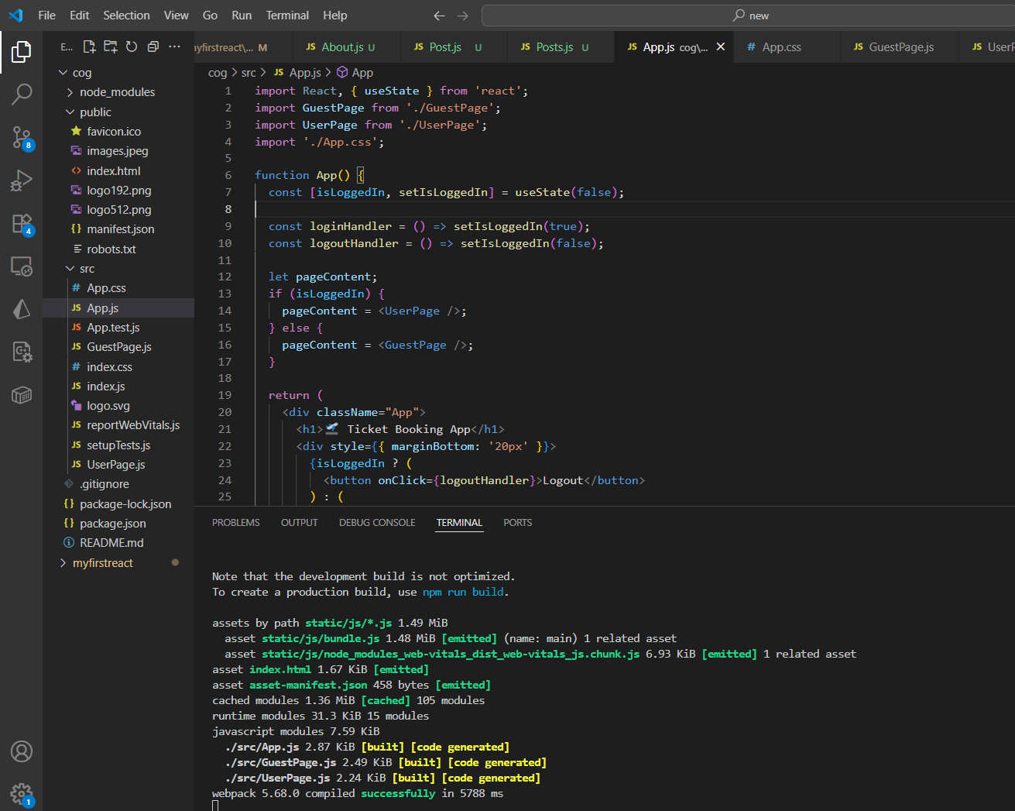
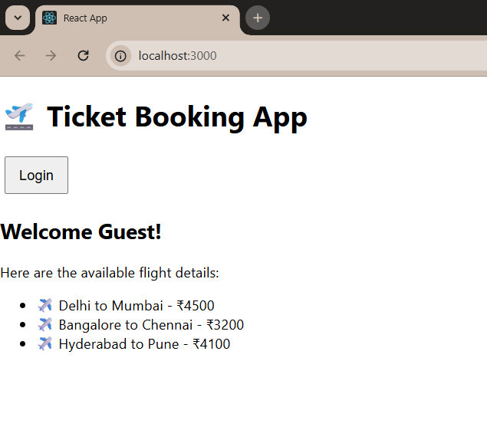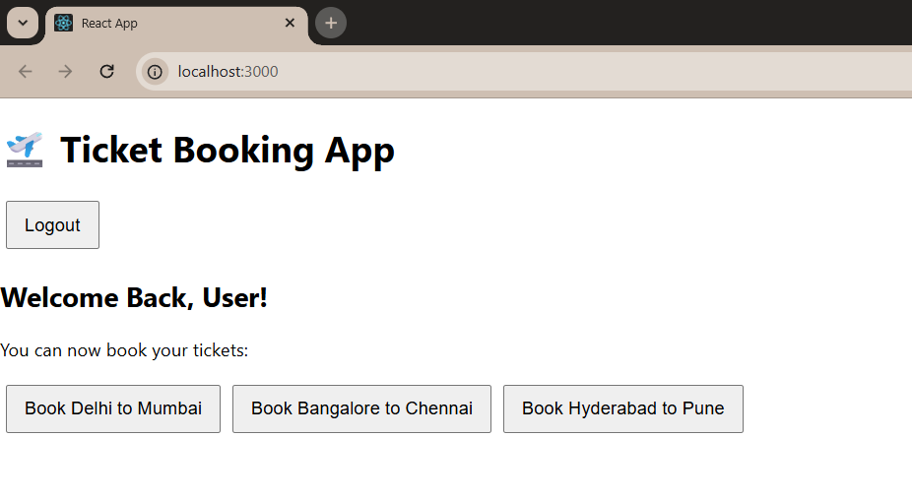

13. ReactJS-HOL

Step 1: Create React Project
In your terminal (VS Code):
npx create-react-app BlogApp
cd BlogApp

Step 2: Create Components Folder
In the src/ folder:
- Right-click src > New Folder → name it Components
- Inside Components, create these 3 files:
  - BookDetails.js
  - BlodDetails.js
  - CourseDetails.js
Step 3: Code for Each Component

BookDetails.js

import React from 'react';

const BookDetails = () => {
const books = [
{ id: 1, title: 'React Mastery', author: 'Dan Abramov' },
{ id: 2, title: 'JavaScript Essentials', author: 'Kyle Simpson' }
];

return (
<div>
<h2>📚 Book Details</h2>
<ul>
{books.map(book => (
<li key={book.id}>
<strong>{book.title}</strong> by {book.author}
</li>
))}
</ul>
</div>
);
};

export default BookDetails;

BlogDetails.js

import React from 'react';

const BlogDetails = () => {
const blogs = [
{ id: 1, title: 'Learning React in 2025' },
{ id: 2, title: 'The Rise of TypeScript' }
];

return (
<div>
<h2> Blog Posts</h2>
<ul>
{blogs.map(blog => (
<li key={blog.id}>{blog.title}</li>
))}
</ul>
</div>
);
};

export default BlogDetails;

CourseDetails.js

import React from 'react';

const CourseDetails = () => {
const courses = [
{ id: 1, name: 'Frontend Basics' },
{ id: 2, name: 'Advanced React' }
];

return (
<div>
<h2> Course Details</h2>
<ul>
{courses.map(course => (
<li key={course.id}>{course.name}</li>
))}
</ul>
</div>
);
};

export default CourseDetails;

Step 4: Modify App.js to Use Components
In src/App.js, update the code like this:
import React, { useState } from 'react';
import BookDetails from './BookDetails';
import BlogDetails from './BlogDetails';
import CourseDetails from './CourseDetails';
import './App.css';

function App() {
const [selected, setSelected] = useState('books');

// Method 1: if-else
let component;
if (selected === 'books') {
component = <BookDetails />;
} else if (selected === 'blogs') {
component = <BlogDetails />;
} else {
component = <CourseDetails />;
}

return (
<div className="App">
<h1>Blogger App</h1>

<div>
<button onClick={() => setSelected('books')}>Books</button>
<button onClick={() => setSelected('blogs')}>Blogs</button>
<button onClick={() => setSelected('courses')}>Courses</button>
</div>

<hr />

{/* Method 2: element variable (above) */}
{component}

{/* Method 3: Ternary Operator */}
{/*
selected === 'books' ? <BookDetails /> :
selected === 'blogs' ? <BlogDetails /> :
<CourseDetails />
*/}

{/* Method 4: Logical && (not used here directly) */}
{/* {selected === 'books' && <BookDetails />} */}
</div>
);
}

export default App;

Step 5: Start the App
In your terminal:
npm start
Then open your browser and go to:
http://localhost:3000

